Design 1 Promotional Billboard Quiz Name: ________________________

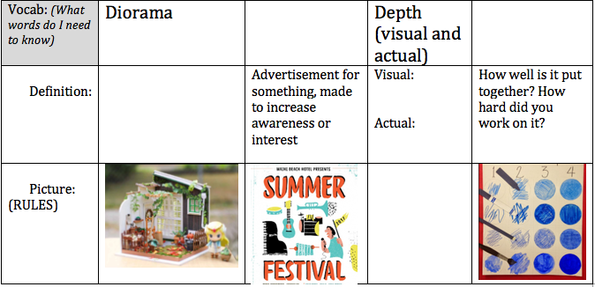

Design 1 Promotional Billboard Quiz Name: ________________________

